**Question No: 01**

**(b) Which type of font has jaggies? Explain why it occurs. 2**

**Ans:**

Jaggies are the jagged edges you see when a bitmapped image is resized. It is a consequence of the underlying array of pixels from which the image is composed.

**Question No: 02**

**(a) Briefly discuss the DPCM coding scheme. 4**

**Ans:**

Differential Pulse Code Modulation is exactly the same as Predictive Coding, Predictive coding except that it incorporates a quantizer step. Quantization is as in PCM and can be uniform or nonuniform. We should adopt some nomenclature for signal values. We shall call the original signal *f*n, the predicted signal *f*ˆn, and the quantized, reconstructed signal *f*˜n. How DPCM operates is to form the prediction, form an error *e*n by subtracting the prediction from the actual signal, then quantize the error to a quantized version, ˜*e*n. The equations that describe DPCM are as follows:

*f*ˆn = function of ( *f*˜n−1, *f*˜n−2, *f*˜n−3, . . .)

*e*n = *f*n − *f*ˆn

˜*e*n = *Q*[*e*n]

transmit codeword( ˜*e*n)

reconstruct: *f*˜n = *f*ˆn + *e*˜n

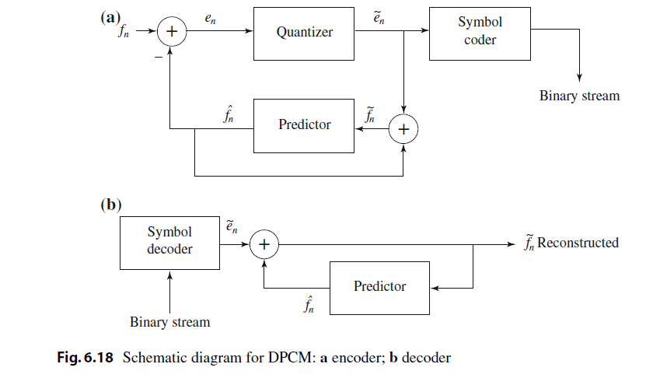

**Question No: 03**

**(a) Define color LUT? Briefly discuss the process to make a 8 bit color LUT out of 24 bit color. 4.5**

**Ans:**

**Color LUT:**

**LUT** (known as **Lookup Table**), is a term used to describe a predetermined array of numbers that provide a shortcut for a specific computation. In the context of **color** grading, a **LUT** transforms **color** input values (camera) to your desired output values (final footage).

**(b) What is dithering? When dithering is needed? Briefly discuss. 3**

**Ans:**

**Dithering:**

Image dithering is a technique to create the illusion of color depth in images displayed on devices with a limited color palette. The colors that are not available in the palette are approximated by a mixture of pixels from the palette.

**Needed of Dithering:**

* Dithering is used to calculate patterns of dots such that values from 0 to 255 correspond to patterns that are more and more filled at darker pixel values, for printing on a 1-bit printer.
* The main strategy is to replace a pixel value by a larger pattern, say 2×2 or 4×4, such that the number of printed dots approximates the varying sized disks of ink used in analog, in halftone printing (e.g., for newspaper photos).

◦ Half-tone printing is an analog process that uses smaller or larger filled circles of black ink to represent shading, for newspaper printing.

* If we use an n×n matrix of on-off 1-bit dots, we can represent n2+1 levels of intensity resolution.

◦ Three dots filled in any way counts as one intensity level.

* For example, if we use a 2×2 dither matrix



**© If you print an image (240*180*8) on a paper (12.8*9.6 inch) by printer with 300*300 dpi, what is the size of each pixel (dots)?**

**1.25**

**Question No: 04**

**(b) What is the main difference between the H.261 and MPEG video compression algorithms? 2**

**Ans:**

**Main difference:**

H 261 has I and P frames. Mpeg introduces additional B frame for backward interpolated prediction of frames.

**H.261 vs MPEG:**

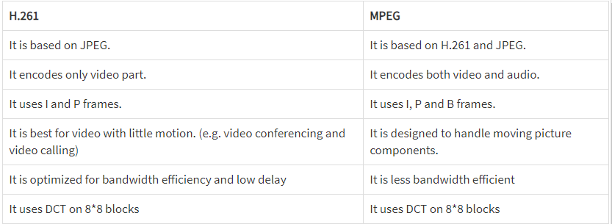

**© MPEG has a variety of different standards, i.e. MPEG-1, MPEG-2, MPEG-4, MPEG-7, MPEG-21. Why have such standards envolved?**

**4.75**

**Ans:**

Different MPEG standard have been developed for developing target domains that need different compression approaches and now formats for integration and interchange of multimedia data.

**MPEG-1** was targetted at Source Input Format (SIF): Video Originally optimized to work at video resolutions of 352x240 pixels at 30 frames/sec (NTSC based) or 352x288 pixels at 25 frames/sec (PAL based) but other resolutions possible.

**MPEG-2** addressed issues directly related to digital television broadcasting,

**MPEG-4:** Originally targeted at very low bit-rate communication (4.8 to 64 kb/sec).

**MPEG-7** targetted at Multimedia Content Description Interface.

**MPEG-21** targetted at Multimedia Framework: Describing and using Multimedia content in a unifed framework.